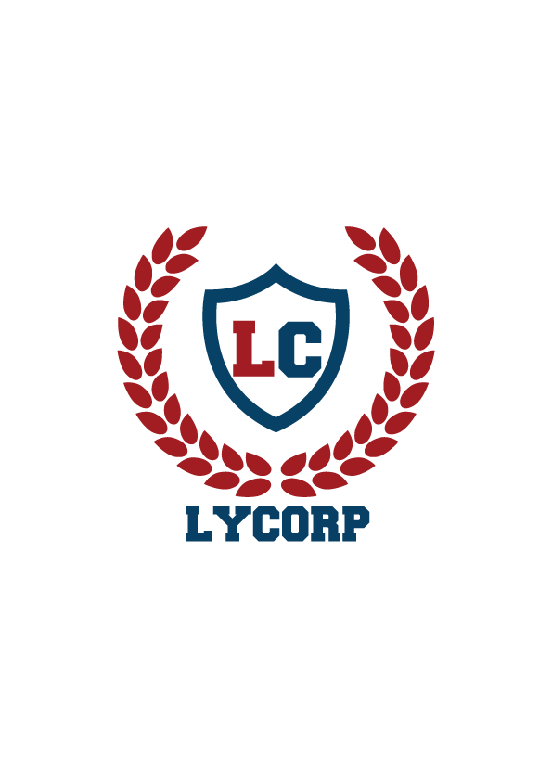

**Lyceum’s Entrepreneurs of Tomorrow**

**Lights, Camera, Action!**

(Maximum Marks 10 for each category)

|  |  |  |  |  |  |  |  |
| --- | --- | --- | --- | --- | --- | --- | --- |
| **Team name** | **Innovation and Idea:** Effective promotion | **Visual Design:** Appearance and use of color | **Scale of effect** | **Brand Awareness:**  Inspire trust, confidence and believability. | | **Total**  **(40)** | **Comments** |
| **MERAKI** |  |  |  |  | |  |  |
| **BUY CORP** |  |  |  |  | |  |  |
| **LOX N BOX** |  |  |  |  | |  |  |
| **INNOVATORS** |  |  |  |  | |  |  |
| **KEROSENE** |  |  |  |  | |  |  |
| **3MNK** |  |  |  |  | |  |  |
| **MARKETING MUESTROS** |  |  |  |  | |  |  |
| **CORPORATE NAZIS** |  |  |  |  | |  |  |
| **THE A-TEAM** |  |  |  |  | |  |  |
| **THE S-SQUAD** |  |  |  |  | |  |  |
| **THE MARKETEERS** |  |  |  |  | |  |  |
| **THE BLAZE** |  |  |  |  | |  |  |
| **THRIAMUOS** |  |  |  |  | |  |  |
| **LE CORP TITANS** |  |  |  |  | |  |  |
| **THE B-TEAM** |  |  |  |  | |  |  |
| **ENIGMA** |  |  |  |  | |  |  |
| **WHITE COLLAR CREW** |  |  |  |  | |  |  |
| **THE TYCOONS** |  |  |  |  | |  |  |
| **IMPRESSANIOS** |  |  |  | |  |  |  |
| **XYZ** | |  |  |  | |  |  |  | |